Chapter 19, Problem 28.

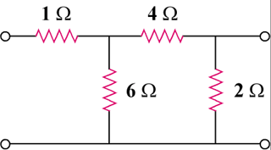
In the circuit of Fig.19.65, the input port is connected to a 1-A dc current source. Calculate the power dissipated by the 2-Ω resistor by using the y parameters. Confirm your result by direct circuit analysis.

8 Ω

4 Ω

12 Ω

2 Ω

Figure 19.65
For Probs. 19.1 and 19.28.

